Chapter Three
Demand, Supply, and Market equilibrium

ANSWERS TO END-OF-CHAPTER QUESTIONS

3-1 Explain the law of demand. Why does a demand curve slope downward? How is a market demand curve derived from individual demand curves?

As prices change because of a change in supply for a commodity, buyers will change the quantity they demand of that item. If the price drops, a larger quantity will be demanded. If the price rises, a lesser quantity will be demanded.

The demand curve slopes downward because, as observation and common sense tell us, people buy more of a product when the price is lower. Prices are an obstacle to buying, so the lower the price, the lower the obstacle, and the more people will buy.

A market demand curve is derived by horizontally adding individual demand curves.

3-2 What are the determinants of demand? What happens to the demand curve when each of these determinants changes? Distinguish between a change in demand and a change in the quantity demanded, noting the cause(s) of each.

The fundamental determinant of demand is the price of the commodity under consideration: a change in price causes movement along the commodity’s demand curve. This movement is called a change in quantity demanded. Decreased price leads to movement down the demand curve: There is an increase in quantity demanded. Increased price leads to movement up the demand curve: There is a decrease in quantity demanded.

In addition, there are determinants of demand, which are factors that may shift the demand curve, i.e., cause a “change in demand.” These are the number of buyers, the tastes (or desire) of the buyers for the commodity, the income of the buyers, the changes in price of related commodities (substitutes and complements), and expectations of the buyers regarding variables such as the future price of the commodity under discussion, and future income.

The following will lead to increased demand: more buyers, greater desire for the commodity, higher incomes (assuming a normal good), lower incomes (assuming an inferior good), an increased price of substitutes, a decreased price of complements, and an expectation of higher future prices or incomes. This increased demand will show as a shift of the entire demand curve to the right.

The reverse of all the above will lead to decreased demand and will show as a shift of the entire demand curve to the left.

3-3 What effect will each of the following have on the demand for small automobiles such as the Mini Cooper or Smart car?

a. Small automobiles become more fashionable.

b. The price of large automobiles rises.

c. Income declines and small autos are an inferior good.

d. Consumers anticipate that the price of small autos will greatly come down in the near future.

e. The price of gasoline substantially drops.

Demand increases in (a), (b), and (c); decreases in (d). The last one (e) is ambiguous. As autos and gas are complements, one could argue that the decrease in gas prices would stimulate demand for all cars, including small ones. However, one could also argue that small cars are attractive to consumers because of fuel efficiency, and that a decrease in gas prices effectively reduces the price of the “gas guzzling” substitutes. That would encourage consumers to switch from smaller to larger cars (SUVs), and demand for small automobiles would fall. [The latter argument is the stronger of the two, but it presents a good illustration of the complexity of many of these changes.]

3-4 Explain the law of supply. Why does the supply curve slope upward? How is the market supply curve derived from the supply curves of individual producers?

As prices rise because of increased demand for a commodity, producers find it more and more profitable to increase the quantity they offer for sale; that is, the supply curve will slope upward from left to right. Clearly, firms would rather sell at a higher price than at a lower price. Moreover, it is necessary for firms to demand a higher price as they increase production. This comes about because as they produce more and more, they start to run up against capacity constraints and costs rise. At any given time, a plant has a given size. As production increases, the firm will need to add an extra shift and then a third shift, both perhaps at higher wages. It may run out of warehouse space and have to rent at higher cost from another firm. It may have to pay extra to get increasingly urgent raw material, and so on.

The market supply curve is derived by horizontally adding the individual supply curves.

3-5 What are the determinants of supply? What happens to the supply curve when each of these determinants changes? Distinguish between a change in supply and a change in the quantity supplied, noting the cause(s) of each.

The fundamental determinant of supply is the price of the commodity. As price increases, the quantity supplied increases. An increase in price causes a movement up a given supply curve. A decrease in price causes a movement down a given supply curve.

The non-price determinants of supply are: resource (input) prices, technology, taxes and subsidies, prices of other related goods, expectations, and the number of sellers. If one or more of these change, there will be a change in supply and the whole supply curve will shift to the right or the left.

The following will cause an increase in supply: a decrease in resource (input) prices; improved (lower cost) technology; a decrease in business taxes, an increase in subsidies to business; a decrease in the price of another commodity that this firm was making, provided that commodity is a substitute in production (the firm can switch from the now lower priced one to our commodity); an expectation of lower prices in the future; and an increase in the number of sellers. The increase in supply caused by the noted change in one or more of the above will cause the entire supply curve to shift to the right. More will now be supplied at any given price. Alternatively expressed, any given amount will now be supplied at a lower price.

The reverse of any or all the above changes in the determinants of demand will cause a decrease in demand and will be shown as a shift of the supply curve to the left. Less will now be supplied at any given price. Alternatively expressed, any given amount will now be supplied at a higher price.

3-6 What effect will each of the following have on the supply of automobile tires?

a. A technological advance in the methods of producing tires.

b. A decline in the number of firms in the tire industry.

c. An increase in the price of rubber used in the production of tires.

d. The expectation that the equilibrium price of auto tires will be lower in the future than it is currently.

e. A decline in the price of large tires used for semi-trucks and earth hauling rigs (with no change in the price of auto tires).

f. The levying of a per-unit tax in each auto tire sold.

g. The granting of a 50-cent-per-unit subsidy for each auto tire produced.

Supply increases in (a), (d), (e), and (g); decreases in (b), (c), and (f).

3-7 “In the latte market, demand often exceeds supply and supply sometimes exceeds demand.” “The price of a latte rises and falls in response to changes in supply and demand.” In which of these two statements are the terms “supply” and “demand” used correctly? Explain.

In the first statement “supply” and “demand” are used incorrectly. Supply and demand are both schedules or curves that intersect where quantity supplied and quantity demanded are equal. One cannot talk of curves that intersect as exceeding or not exceeding each other.

Supply and/or demand can change (the entire curves can shift). Each time this happens, it will create a new intersection of the two curves that will lead to changes in the equilibrium quantity and price of corn. Thus, the terms “supply” and “demand” are used correctly in the second statement.

3-8 Suppose the total demand for wheat and the total supply of wheat per month in the Kansas City grain market are as follows:
Thousands  of bushels  demanded | Price  per  bushel | Thousand  of bushels  supplied | Surplus (+)  or  shortage (-)
85  80  75  70  65  60 | $3.40  3.70  4.00  4.30  4.60  4.90 | 72  73  75  77  79  81 | _____  _____  _____  _____  _____  _____

a. What is the equilibrium price? What is the equilibrium quantity? Fill in the surplus-shortage column and use it to explain why your answers are correct.

b. Graph the demand for wheat and the supply of wheat. Be sure to label the axes of your graph correctly. Label equilibrium price P and equilibrium quantity Q.

c. Why will $3.40 not be the equilibrium price in this market? Why not $4.90? “Surpluses drive prices up; shortages drive them down.” Do you agree?

Data from top to bottom: -13; -7; 0; +7; +14; and +21.

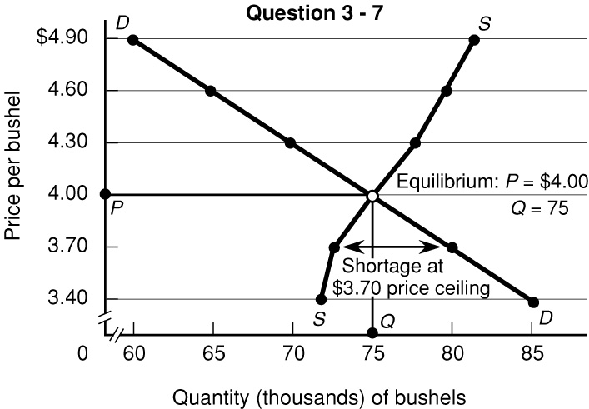

(a) Pe = $4.00; Qe = 75,000. Equilibrium occurs where there is neither a shortage nor surplus of wheat. At the immediately lower price of $3.70, there is a shortage of 7,000 bushels. At the immediately higher price of $4.30, there is a surplus of 7,000 bushels. (See graph).

(b) See graph.

(c) Because at $3.40 there will be a 13,000 bushel shortage which will drive price up. Because at $4.90 there will be a 21,000 bushel surplus which will drive the price down. The quotation is incorrect; the opposite is true.

3-9 How will each of the following changes in demand and/or supply affect equilibrium price and equilibrium quantity in a competitive market; that is, do price and quantity rise, fall, remain unchanged, or are the answers indeterminate because they depend on the magnitudes of the shifts? Use supply and demand diagrams to verify your answers.

a. Supply decreases and demand is constant.

b. Demand decreases and supply is constant.

c. Supply increases and demand is constant.

d. Demand increases and supply increases.

e. Demand increases and supply is constant.

f. Supply increases and demand decreases.

g. Demand increases and supply decreases.

h. Demand decreases and supply decreases.

(a) Price up; quantity down;

(b) Price down; quantity down;

(c) Price down; quantity up;

(d) Price indeterminate; quantity up;

(e) Price up; quantity up;

(f) Price down; quantity indeterminate;

(g) Price up, quantity indeterminate;

(h) Price indeterminate and quantity down.

3-10 For each stock in the stock market, the number of shares sold daily equals the number of shares purchased. That is, the quantity of each firm’s shares demanded equals the quantity of its shares supplied. So, if this equality always occurs, why do the prices of stock shares ever change?

During any given stock trading session, there will be both prospective buyers and sellers, each willing to buy or sell a certain number of shares depending on price. If at the current price (e.g. the day’s opening price) the quantity of shares demanded exceeds the quantity of shares supplied, buyers must increase their price offers to induce sellers to offer enough shares. This will cause share prices to rise until quantity demanded equals quantity supplied. Suppose that during the trading session there is a report of bad economic news. Sellers may respond by trying to sell more shares than buyers are wanting at the current price. In order to find enough willing buyers, sellers will have to offer their shares at lower prices. On any given trading day, there will be multiple equilibrium prices, many of them not lasting for more than a few minutes (or even seconds).

3-11 Critically evaluate: “In comparing the two equilibrium positions in Figure 3.7a, I see that a larger amount is actually purchased at a higher price. This refutes the law of demand.”

The key point here is that the second equilibrium occurs after demand has increased, that is demand has shifted because of a change in determinants, which has caused buyers to want more at every price compared to the original D1 demand curve and schedule. Each equilibrium price refers to a different demand situation. Therefore, the fact that more is purchased at a higher price when demand increases, does not refute the law of demand. Note that on the second demand curve and schedule, more would still be purchased at a lower price.

